**Q1. Problem Statement**

Indian Valley University provides education in different courses and has more than 200 faculties working in various departments. The university wants to calculate the annual salary for each faculty member. Basic salary is provided for all faculties and an additional component is paid based on their designation or qualification. You need to help the university in creating an application for them by implementing the classes based on the class diagram and description given below.

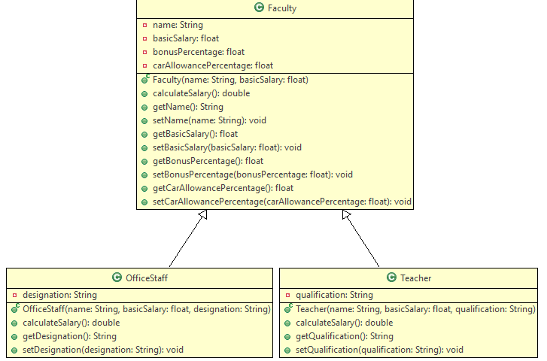

**Method Description**

**Faculty**

**Faculty (String name, float basicSalary)**

* Initialize the name and basicSalary with the values passed to the constructor.
* Set the bonusPercentage and carAllowancePercentage to 4 and 2.5 respectively.

**calculateSalary()**

* Calculate and return the total salary of a faculty member by adding all the three components - basicSalary, bonus and car allowance.
* Implement the getter and setter methods appropriately.

**OfficeStaff**

**OfficeStaff()**

* Initialize the name, basicSalary and designation with the values passed to the constructor.

**calculateSalary()**

* Calculate and return the salary of an office staff by adding an additional pay to the salary based on the designation. Use the details given below for calculating the additional pay. There will be no additional pay for other designations.

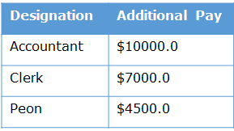

Implement the getter and setter methods appropriately.

**Teacher**

**Teacher(String name, float basicSalary, String qualification)**

* Initialize the name, basicSalary and qualification with the values passed to the constructor.

**calculateSalary()**

* Calculate and return the salary of a teacher by adding an additional pay to the salary based on the qualification. Use the details given below for calculating the additional pay. There will be no additional pay for other qualifications.

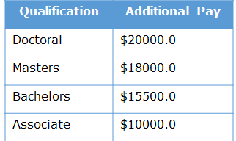

Implement the getter and setter methods appropriately.

Perform case sensitive comparison wherever applicable.

Hint: Use String. Equals () for comparing qualification and designation.

Q2. Design a registration form using Swings in Java.